**Write a C program to implement hashing using Linear Probing method**

**INPUT:**

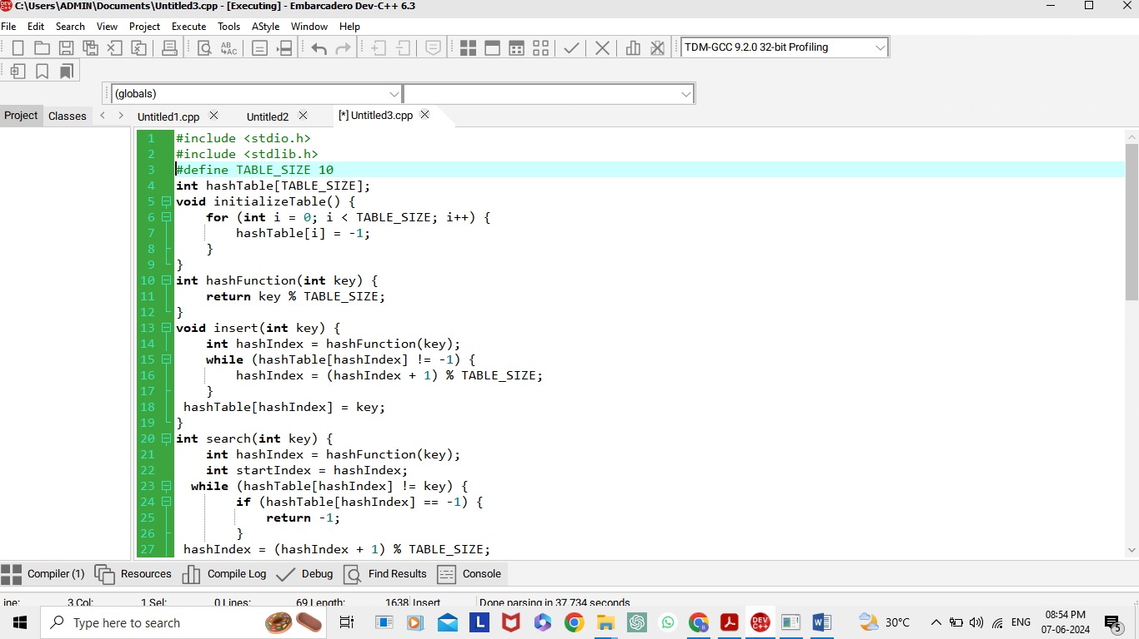

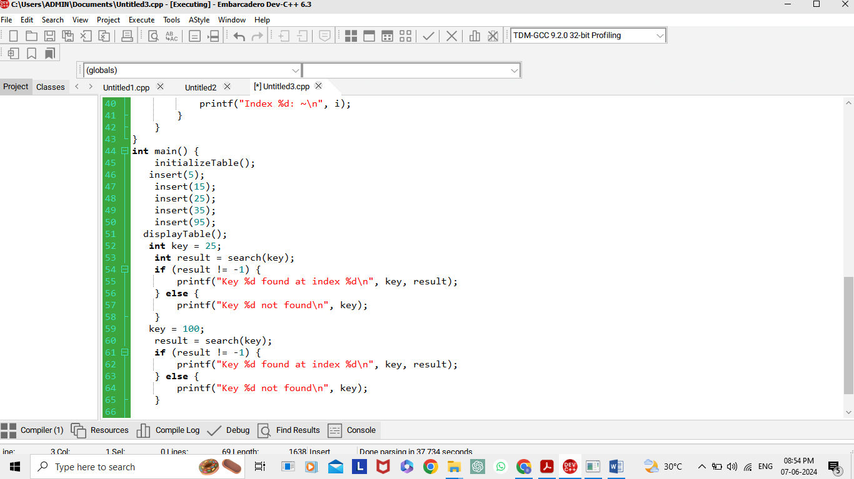

**OUTPUT:**

